

JAVA PROJECT REPORT ON

RETAIL SHOP INVENTORY AND PRODUCT BILLING MANAGEMENT SYSTEM

Submitted by HAREESHNY
25BCS021

Under the Guidance of
Dr. Boopalan Sundaramoorthy
Technical Trainer


Technical Head
Technical Department, KG College of Arts and Science

Academic Year: 2025 – 2026

APRIL 2026
Semester: II

DECLARATION
I hereby declare that the project entitled “RETAIL SHOP INVENTORY AND PRODUCT BILLING MANAGEMENT SYSTEM” submitted in partial fulfillment of the requirements for the course JAVA PROGRAMMING is a record of my original work carried out under the guidance of Dr. BOOPALAN SUNDARAMOORTHY, Technical
Trainer, Technical Department, KG College of Arts and Science.

I further declare that this project has not been submitted previously, either in part or in full, for the award of any degree, diploma, or other similar title, at this or any other institution.
I have acknowledged all sources of information used in this project wherever applicable.

April 2026 Coimbatore

HAREESHNY M

CERTIFICATE
This is to certify that the project entitled “RETAIL SHOP INVENTORY AND PRODUCT BILLING MANAGEMENT SYSTEM” is a bona fide work carried out by HAREESHNY M, I - BSC CS ‘A’ [2025 - 2028], Department Of Computer Science, KG College of Arts & Science, in partial fulfillment of the requirements for the course Java Programming.
This project has been completed under my supervision and guidance during the academic period April 2026.

Place:
Date:

Submitted for the Viva-Voce Examination held on

Guide: Head of the Department

(Technical Head, KGCAS)
(Technical Trainer, KGCAS)

(Technical Head, KGCAS)

TABLE OF CONTENTS

S. No. | Topics | Page. No.
1 | Introduction
1.1 | Objective
1.2 | Overview
1.3 | Features
2 | Program Analysis
2.1 | Problem Definition
2.2 | Project Overview
2.3 | Scopes and Limitations
3 | System Design
3.1 | Modules
4 | Methodology
4.1 | Problem Analysis
4.2 | System Design
4.3 | Program Development
4.4 | Testing and Validation
4.5 | Result and Documentation
4.6 | Algorithm
4.7 | Flowchart
5 | Source Code
6 | Input and Output Screens
7 | Discussion and Conclusion
7.1 | Discussion
7.2 | Conclusion
8 | References

ABSTRACT

The Retail Shop Inventory and Product Billing Management System is a software application designed to automate and simplify the management of inventory and billing processes in retail shops. In many small retail businesses, inventory tracking and billing are often handled manually, which can lead to errors in stock management, incorrect billing, and delays in customer service.
This project aims to provide an efficient and user-friendly system that maintains product records, tracks stock levels, and generates accurate bills for customers. The system allows users to add, update, and delete product details, monitor available stock, and automatically update inventory after each sale. It also calculates the total bill amount based on selected products, quantities, and applicable taxes such as GST.
The application is developed using core programming concepts, including classes, objects, loops, conditional statements, and exception handling. It can be implemented as a console-based application or with a graphical user interface for better usability.
The main objective of the system is to improve accuracy in inventory management, reduce manual effort, and enhance the speed of billing operations. The system generates clear and organized invoices displaying product details, quantities, prices, tax, and final payable amount.
This project demonstrates the practical application of programming concepts and serves as a foundation for developing advanced retail management systems in the future.

INTRODUCTION
In the retail industry, inventory and billing systems are essential for managing daily operations and ensuring customer satisfaction. Many small shops still rely on manual methods such as handwritten records and calculators, which often lead to errors, delays, and difficulty in maintaining accurate records.
With the advancement of technology, automated systems have become important for improving efficiency and accuracy. A computerized system helps shopkeepers manage product details, track stock levels in real time, and generate bills quickly while maintaining proper sales records.
The Retail Shop Inventory and Product Billing Management System is designed to automate inventory management and billing processes. It allows users to add, update, and delete product details, monitor stock availability, and generate bills that include item details, prices, GST, and final amount, while automatically updating inventory after each sale.
The primary goal of this system is to reduce manual effort, improve accuracy in inventory and billing processes, and provide faster service to customers. It ensures efficient, reliable, and error-free retail operations and demonstrates the practical use of programming in
real-world applications.

Objective
The main objective of the Retail Shop Inventory and Product Billing Management System is to develop a simple and efficient application using Core Java that automates the process of inventory management and product billing in retail shops.
The specific objectives of this project are:
    - To design and develop a Java-based retail shop inventory and billing system.
    - To automate the calculation of product prices and total bill amount.
    - To maintain accurate inventory records and stock levels.
    - To reduce manual errors in billing and stock management.
    - To provide a user-friendly system for shopkeepers to manage products and generate invoices easily.
    - To update inventory automatically after each sale.
    - To generate a clear and organized bill for customers.
    - To demonstrate the implementation of Core Java programming concepts such as classes, objects, methods, loops, and conditional statements.

Overview
The Retail Shop Inventory and Product Billing Management System is a Java-based,
menu-driven application designed to manage product inventory and generate bills efficiently. It allows shopkeepers to maintain product details such as price and stock, select items, enter quantities, and automatically calculate the total bill including applicable taxes like GST.
The system also updates inventory after each transaction, ensuring accurate stock tracking and preventing shortages or over-selling. By reducing manual work and calculation errors, the system improves efficiency and speeds up billing operations.
This application can be developed as a console-based program or with a graphical user interface (GUI) using Java Swing. It demonstrates the practical use of Java programming in real-world retail environments.

Features
The Retail Shop Inventory and Product Billing Management System includes the following main features:
    - Product Display – Displays a list of available products in the shop along with their prices and stock details.
    - Product Selection – Allows the user to select products and enter the quantity purchased by the customer.
    - Automatic Bill Calculation – Automatically calculates the total amount based on selected products and quantities.
    - Tax Calculation – Calculates applicable taxes such as GST and adds them to the total bill.
    - Invoice Generation – Generates a detailed bill showing product names, quantities, prices, subtotal, tax, and final amount.
    - Inventory Management – Maintains and updates stock levels after each transaction.
    - User-Friendly Interface – Provides a simple and easy-to-use menu-driven interface for shopkeepers.
    - Fast Billing Process – Reduces the time required to generate customer bills and improves efficiency.
    - Product Management – Allows adding, updating, and deleting product details in the inventory.

PROGRAM ANALYSIS
Program analysis is a key phase in software development that focuses on understanding the problem and identifying system requirements. It helps in designing an efficient solution to improve accuracy and performance.

Problem Definition
In many retail shops, inventory management and billing are done manually using paper records or simple calculators. This method leads to inefficiencies and difficulties in managing daily operations.
Some common problems include:
    - Errors in bill calculation
    - Time-consuming billing process
    - Difficulty in managing stock
    - Lack of proper records
    - Slow service during busy hours
Therefore, there is a need for an automated system that can efficiently manage inventory and billing. The Retail Shop Inventory and Product Billing Management System provides a computerized solution to improve accuracy, reduce manual effort, and enhance overall efficiency.

Project Overview
The Retail Shop Inventory and Product Billing Management System is a Java-based application developed to simplify inventory management and billing processes in retail shops. It provides a menu-driven interface where users can manage products, track stock, and generate bills efficiently.
The system allows users to select products, enter quantities, and automatically calculates the total cost along with applicable taxes like GST. It also updates the inventory after each transaction, ensuring accurate stock management.
The system includes the following functionalities:
    - Displaying product list with prices and stock details
    - Selecting products and entering quantity
    - Automatic calculation of total bill
    - Calculating subtotal and tax amount
    - Generating final bill for the customer
    - Updating inventory after each sale
This project is implemented using Core Java programming concepts and can be developed as either a console-based application or a Java Swing GUI application.

Scopes and Limitations Scope:
    - Managing product details and stock
    - Processing customer purchases
    - Automatic bill calculation
    - Generating invoices
    - Updating inventory after each sale
    - Used in retail shops and small stores

Limitations:
    - Suitable for small shops only
    - No multi-user support
    - Risk of data loss
    - Limited features
    - Requires basic computer knowledge

The system can be used in:
    - Retail shops
    - Supermarkets
    - Small stores
    - Grocery shops
    - Other small retail businesses

SYSTEM DESIGN
System design is the phase where the structure and components of the system are planned before implementation. In this stage, the system is divided into different modules, and the workflow is defined to ensure efficient and organized development.
The Retail Shop Inventory and Product Billing Management System is designed as a menu-driven application where users can manage products, track stock, and generate bills automatically.
The system is divided into several modules, each handling a specific function of the system.

Modules
The main modules of the Retail Shop Inventory and Product Billing Management System
are explained below:

Product Display Module
Displays the list of available products along with their prices and stock details.

Product Selection Module
Allows users to select products and enter the quantity required. It stores order details temporarily.

Inventory Management Module
Manages product details such as adding, updating, deleting items, and automatically updates stock after each sale.

Bill Calculation Module
Calculates total price, subtotal, GST, and final bill amount automatically.

Invoice Generation Module
Generates a detailed bill including product name, quantity, price, tax, and total amount.

Exit Module
Allows the user to safely exit the system after completing operations.

METHODOLOGY
Methodology describes the process followed to develop the project. It explains the steps taken from understanding the problem to designing, implementing, testing, and documenting the system.
For the Retail Shop Inventory and Product Billing Management System, a structured development approach is followed to ensure efficiency and accuracy in managing inventory and billing operations.
The development process includes the following stages:

- Problem Analysis
- System Design
- Program Development
- Testing and Validation
- Result and Documentation

Problem Analysis

In this phase, the problems in existing manual retail shop systems are studied and analyzed. The requirements are identified to improve inventory management and billing efficiency.The main problems identified are:
    - Manual calculations may lead to billing errors
    - Billing process is time-consuming
    - Difficulty in managing multiple products and customer orders
    - Lack of proper inventory and sales records

Based on these issues, an automated system is required to simplify operations, reduce errors, and improve accuracy in inventory and billing management.

System Design

In this stage, the overall structure of the system is designed before coding begins.

The system is divided into modules such as:
- Product Display Module
- Product Selection Module
- Inventory Management Module
- Bill Calculation Module
- Invoice Generation Module
- Exit Module

The program flow and structure are designed so that users can easily interact with the system.

Program Development

After designing the system, the program is implemented using the Java programming language.
The following steps were followed during development:

- Creation of classes and methods for products and inventory
- Implementation of product management
- Writing code for stock calculation and updates
- Handling user input for product details
- Displaying product list and stock sqtatus

Core Java concepts such as classes, objects, loops, conditional statements, and methods
were used during development.

Testing and Validation

Testing ensures that the program works correctly and produces the expected results.Different test cases were used to check the functionality of the system.
Example Test Cases:

Test Case | Expected Result
Add product | Product added successfully
Update product | Product details updated correctly
Delete product | Product removed successfully
Check stock | Correct stock quantity displayed
Generate bill | Accurate bill with total amount
Invalid input | Error handled properly
This phase ensures that the program runs without errors and produces accurate results.

Result and Documentation
accurate bills based on selected products and quantities while updating inventory
After successful testing, the results of the system are documented. The system generates

After successful testing, the results of the system are documented. The system generates

accurate bills based on selected products and quantities while updating inventory

automatically.

The results are demonstrated through program execution and screenshots showing the input and output of the system.
Proper documentation is prepared to explain the design, implementation, and working of the system.

Algorithm

Algorithm for the Retail Shop Inventory and Product Billing Management System:

- Start the program.
- Display the list of available products with their prices and stock details.
- Ask the user to select a product.
- Enter the quantity of the selected product.
- Check whether the required quantity is available in stock.
- If stock is available, calculate the total cost of the selected product.
- Add the cost to the total bill.
- Update the inventory by reducing the sold quantity.
- Repeat steps 3–8 for additional products if required.
- Calculate the GST or tax amount.
- Calculate the final bill amount.
- Display the final bill to the user.
- Generate and store the transaction record.
- End the program.

Flowchart

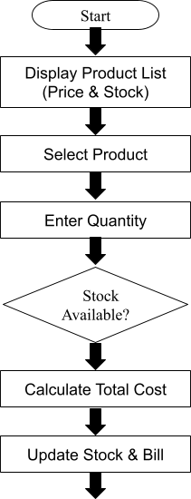
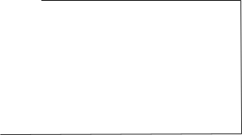
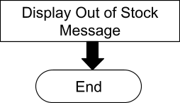

NO
YES

SOURCE CODE
import java.util.Scanner; class Product {
int id;
String name; double price; int stock;
Product(int id, String name, double price, int stock) { this.id = id;
this.name = name; this.price = price; this.stock = stock;
}
void display() {
System.out.println(id + ". " + name + " | Price: " + price +
" | Stock: " + stock);
}
}
public class RetailShopMenu {
public static void main(String[] args) { Scanner sc = new Scanner(System.in); Product[] products = {
new Product(1, "Soap", 30, 50),
new Product(2, "Shampoo", 120, 30),
new Product(3, "Rice", 60, 100),
new Product(4, "Milk", 25, 40)
};
double totalBill = 0;
int choice; do {
System.out.println("\n===== MENU ====="); System.out.println("1. View Products"); System.out.println("2. Buy Product"); System.out.println("3. Generate Bill & Exit"); System.out.print("Enter your choice: ");
choice = sc.nextInt(); switch (choice) {
case 1:
System.out.println("\n--- Product List ---"); for (Product p : products) {
p.display();
}
break; case 2:
System.out.print("Enter Product ID: "); int pid = sc.nextInt();
Product selected = null;
for (Product p : products) { if (p.id == pid) {
selected = p; break;
}
}
if (selected == null) { System.out.println("Invalid product!"); break;
}
System.out.print("Enter Quantity: "); int qty = sc.nextInt();
if (qty > selected.stock) { System.out.println("Out of stock!");
} else {
double cost = qty * selected.price; totalBill += cost;
selected.stock -= qty; System.out.println("Added: " + selected.name); System.out.println("Cost: " + cost);
}
break; case 3:
double gst = totalBill * 0.05; double finalBill = totalBill + gst;
System.out.println("\n------ FINAL BILL ");
System.out.println("Total: " + totalBill); System.out.println("GST: " + gst); System.out.println("Final Amount: " + finalBill); System.out.println("Thank You!");
break; default:
System.out.println("Invalid choice!");
}
} while (choice != 3); sc.close();
}
}

INPUT AND OUTPUT SCREENS

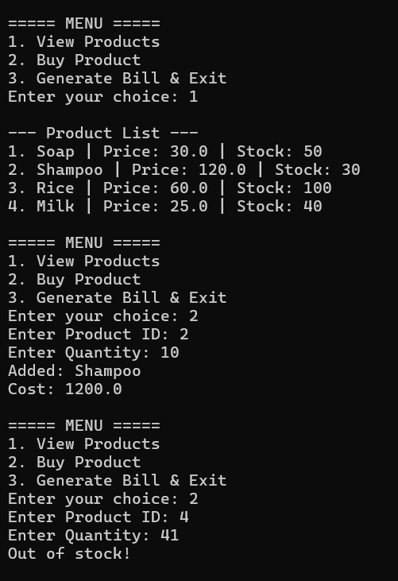

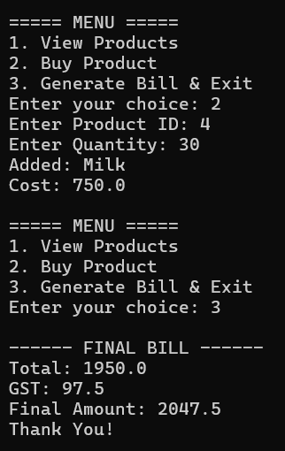
14

DISCUSSION & CONCLUSION

Discussion
The Retail Shop Inventory and Product Billing Management System was developed to automate billing and inventory management in retail shops. The system allows users to view available products, select items, enter quantities, and generate bills efficiently.
During the development process, core Java programming concepts such as loops, conditional statements, and methods were used. The system successfully manages product details, performs accurate billing calculations, and updates inventory records accordingly.
The system was tested with various inputs to ensure proper functionality. The results show that the system reduces manual work, minimizes calculation errors, and improves overall efficiency in managing sales and inventory.

Conclusion
The Retail Shop Inventory and Product Billing Management System successfully demonstrates the practical application of Java programming in developing a real-world retail solution.
The system automates billing operations, maintains product stock, and ensures accurate and fast invoice generation. It helps shopkeepers manage their business more effectively by reducing time and effort.
This project enhances understanding of programming concepts and their real-time usage. The system can be further improved by adding features such as database integration, graphical user interface (GUI), barcode scanning, and online payment options.

REFERENCES

The following resources were referred to during the development of the Retail Shop Inventory and Product Billing Management System:

Books:
Java: The Complete Reference – Herbert Schildt Head First Java – Kathy Sierra and Bert Bates Introduction to Java Programming – Y. Daniel Liang Websites:
Oracle – https://www.oracle.com/java GeeksforGeeks – https://www.geeksforgeeks.org W3Schools – https://www.w3schools.com Javatpoint – https://www.javatpoint.com TutorialsPoint – https://www.tutorialspoint.com

